Innovation Engineering
Cost: $185, less $90 OCAST Training Award subsidy, brings the total cost to $95 per person (up to 3 per company)
Upcoming Innovation Engineering Dates: May 4, 2016
Location: Tulsa Tech, 3638 S. Memorial, Training Center, Room #3
Fax or Email the completed form to: 918-592-1417 or Innovation@okalliance.com

Company: _______________________________________________________________
Billing Contact Information:
Contact Person: _________________________________________________
Contact Email: __________________________________________________
Contact Phone Number: ___________________________________________

Participant One Name: ______________________________________________________
Company Address: _________________________________________________________
City: ___________________ State: _______ Zip Code: ________________________
Work Phone: _____________________ Cell Phone: ___________________________
Email Address: ____________________________________________________________

Participant Two Name: _____________________________________________________
Work Phone: _____________________ Cell Phone: ___________________________
Email Address: ____________________________________________________________

Participant Three Name: _________________________________________________
Work Phone: _____________________ Cell Phone: ___________________________
Email Address: ____________________________________________________________

Space is Limited – Register Today!
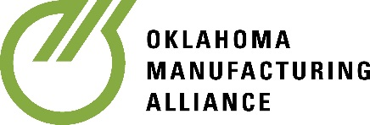
Call or Email: 918-592-0722 or Innovation@okalliance.com

